OSPFv3

By Diego “Daniel” Santos

In this lab we were tasked with taking our previous OSPF lab and turning it into a multiarea OSPFv3 lab using Ipv6 addresses while at the same time adding an additional router to the original topology.

The history of OSPF (Open Shortest Path First) started in 1998 with OSPFv2 utilizing the use of ipv4 addresses to help with router routing with the most recent iteration being OSPFv3 in 2008 using the newer and more plentiful ipv6 addresses and is still being used today in large service provider networks. It was originally created by IETF (Internet Engineering Task Force) as an Interior Gateway Protocol (IGP)

It all started with a basic configuration (Please ignore the names I was listening to anime while I was doing this lab >_<) and adding Ipv6 addresses to each interface with the template of (2001:DB8:0:#::1) and the command (ipv6 unicast-routing)

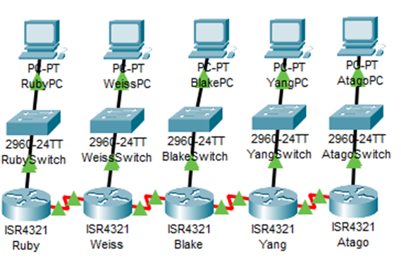After setting up ipv6 on all routers I start setting up link locals on all interfaces (NEVER USE THE SAME LINK LOCAL ON TWO DIFFERENT INTERFACES) or ospfv3 will refuse to work (believe me I know). Using the template of (FE80::#). After setting up the link locals we can start setting up ipv6 on all routers using the commands of [ipv6 router ospf (area-#)] which I used 1 for my area number then make sure to set the apporiate router id using the command [router-id #.#.#.#] then on the serial interfaces that I wanted to set up ospfv3 on I used the commands of [ipv6 ospf 1 area 0] then after all interfaces are set up use the command [clear ospf process] to restart all the ospf on said router.

**Router Configs (PT refused to start when I grabed the configs)**

**Ruby**

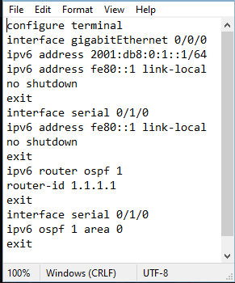

**Weiss**

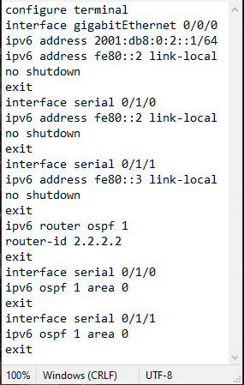

**Blake**

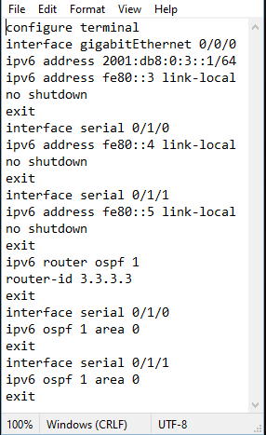

**Yang**

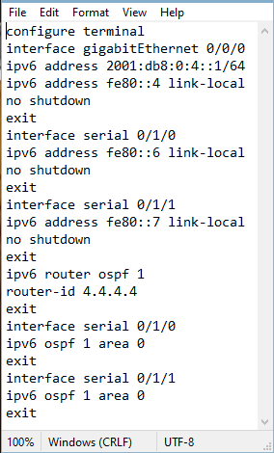

**Atago**

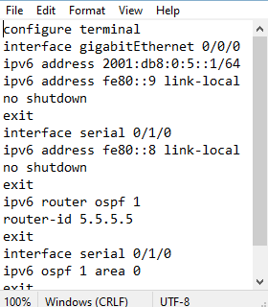

I had a couple of problems when setting up this lab with the first having the same link local on two different interfaces then forgetting about the (clear ip ospf process) to restart the routers.